**OSI Model The OSI 7 Layers**

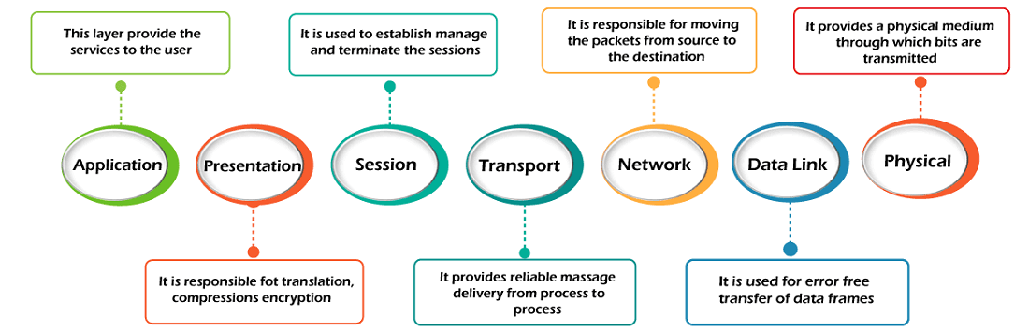

# **OSI Model**

* OSI stands for **Open System Interconnection** is a reference model that describes how information from a [software](https://www.javatpoint.com/software) application in one [computer](https://www.javatpoint.com/what-is-computer) moves through a physical medium to the software application in another computer.
* OSI consists of seven layers, and each layer performs a particular network function.
* OSI model was developed by the International Organization for Standardization (ISO) in 1984, and it is now considered as an architectural model for the inter-computer communications.
* OSI model divides the whole task into seven smaller and manageable tasks. Each layer is assigned a particular task.
* Each layer is self-contained, so that task assigned to each layer can be performed independently.

**7. Application Layer**

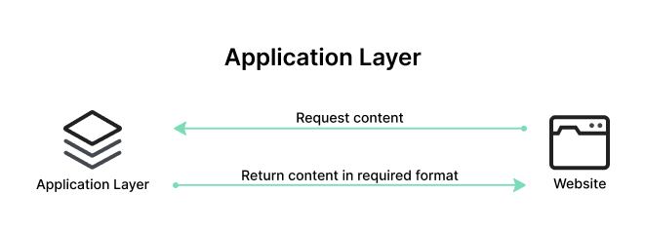

The Application Layer serves as the interface between the end-user applications and the underlying network services. This layer provides protocols and services that are directly utilized by end-user applications to communicate across the network. Key functionalities of the Application Layer include resource sharing, remote file access, and network management.

Examples of protocols operating at the Application Layer include [Hypertext Transfer Protocol (HTTP)](https://www.imperva.com/learn/performance/http2/) for web browsing, File Transfer Protocol (FTP) for file transfers, Simple Mail Transfer Protocol (SMTP) for email services, and Domain Name System (DNS) for resolving domain names to IP addresses. These protocols ensure that user applications can effectively communicate with each other and with servers over a network.

**6. Presentation Layer**

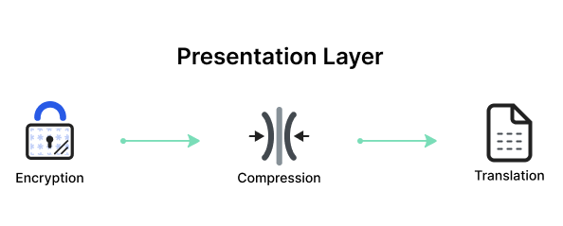

The Presentation Layer, also known as the syntax layer, is responsible for translating data between the application layer and the network format. It ensures that data sent from the application layer of one system is readable by the application layer of another system. This layer handles data formatting, [encryption](https://www.imperva.com/learn/data-security/data-encryption/), and compression, facilitating interoperability between different systems.

One of the key roles of the Presentation Layer is data translation and code conversion. It transforms data into a format that the application layer can understand. For example, it may convert data from ASCII to EBCDIC. It also includes encryption protocols to ensure [data security](https://www.imperva.com/learn/data-security/data-security/) during transmission and compression protocols to reduce the amount of data for efficient transmission.

**5. Session Layer**

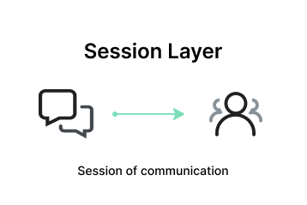

The Session Layer manages and controls the connections between computers. It establishes, maintains, and terminates connections, ensuring that data exchanges occur efficiently and in an organized manner. The layer is responsible for session checkpointing and recovery, which allows sessions to resume after interruptions.

Protocols operating at the Session Layer include Remote Procedure Call (RPC), which enables a program to execute a procedure on a remote host as if it were local, and the session establishment phase in protocols like NetBIOS and SQL. These services enable reliable communication, especially in complex network environments.

**4. Transport Layer**

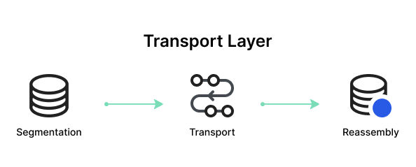

The Transport Layer provides end-to-end communication services for applications. It ensures complete data transfer, error recovery, and flow control between hosts. This layer segments and reassembles data for efficient transmission and provides reliability with error detection and correction mechanisms.

Protocols at this layer include [Transmission Control Protocol](https://www.imperva.com/learn/ddos/tcp-transmission-control-protocol/) (TCP) and [User Datagram Protocol](https://www.imperva.com/learn/ddos/udp-user-datagram-protocol/) (UDP). TCP is connection-oriented and ensures reliable data transfer with error checking and flow control, making it suitable for applications like web browsing and email. UDP is connectionless, offering faster, though less reliable, transmission, suitable for applications like video streaming and online gaming.

**3. Network Layer**

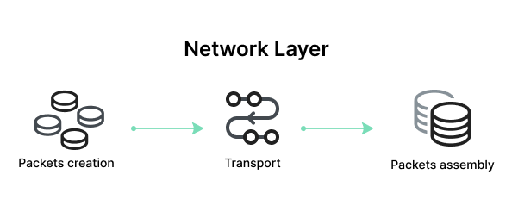

The Network Layer is responsible for data routing, forwarding, and addressing. It determines the best physical path for data to reach its destination based on network conditions, the priority of service, and other factors. This layer manages logical addressing through IP addresses and handles packet forwarding.

Key protocols at this layer include the Internet Protocol (IP), which is important for routing and addressing, Internet Control Message Protocol (ICMP) for diagnostic and error-reporting purposes, and routing protocols like Routing Information Protocol (RIP) that manage the routing of data across networks.

**2. Data Link Layer**

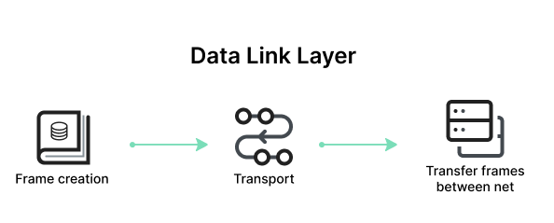

The Data Link Layer is responsible for node-to-node data transfer and error detection and correction. It ensures that data is transmitted to the correct device on a local network segment. This layer manages [MAC (Media Access Control)](https://www.imperva.com/learn/application-security/broken-object-level-authorization-bola/) addresses and is divided into two sublayers: Logical Link Control (LLC) and Media Access Control (MAC).

Protocols and technologies at this layer include Ethernet, which defines the rules for data transmission over local area networks (LANs), and Point-to-Point Protocol (PPP) for direct connections between two network nodes. It also includes mechanisms for detecting and possibly correcting errors that may occur in the Physical Layer.

**1. Physical Layer**

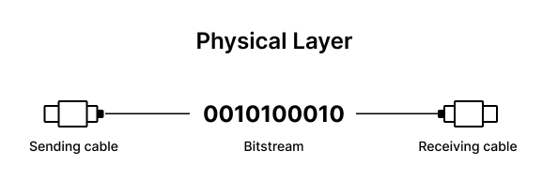

The Physical Layer is responsible for the physical connection between devices. It defines the hardware elements involved in the network, including cables, switches, and other physical components. This layer also specifies the electrical, optical, and radio characteristics of the network.

Functions of the Physical Layer include the modulation, bit synchronization, and transmission of raw binary data over the physical medium. Technologies such as Fiber Optics and Wi-Fi operate at this layer, ensuring that the data physically moves from one device to another in the network.

**How Does Communication Happen in the OSI Model? A Practical Example**

Let’s consider how OSI layers play a role in an everyday activity like sending an email to a person overseas:

* When a user in New York sends an email to a colleague in London, the process starts at the Application Layer (Layer 7). The user’s email client, such as Outlook, uses SMTP (Simple Mail Transfer Protocol) to handle the email message.
* The email is then passed to the Presentation Layer (Layer 6), where it is formatted and encrypted to ensure proper transmission.
* Next, the email moves to the Session Layer (Layer 5), where a session is established between the sender’s email server in New York and the receiver’s email server in London. This layer manages the session, keeping the connection open long enough to send the email.
* The email data then reaches the Transport Layer (Layer 4), where it is divided into smaller packets. TCP ensures these packets are sent reliably and in the correct order.
* At the Network Layer (Layer 3), each packet is assigned source and destination IP addresses, allowing it to be routed through multiple networks, including routers and switches, to reach the recipient in London.
* The Data Link Layer (Layer 2) then uses MAC addresses to handle the packets’ journey across local networks and correcting any errors that occur.
* Finally, the Physical Layer (Layer 1) converts the data into electrical signals, which are transmitted over fiber-optic cables under the Atlantic Ocean.

Upon reaching the recipient’s server in London, the process is reversed:

* The Physical Layer converts the signals back into data packets, which are reassembled at the Data Link Layer.
* The Network Layer ensures the packets have arrived correctly, and the Transport Layer reorders them if necessary.
* The Session Layer maintains the session until the email is fully received.
* The Presentation Layer decrypts and formats the email, and the Application Layer delivers the email to the client, where it appears in their inbox.

**Advantages of OSI Model**

The OSI model helps users and operators of computer networks:

* Determine the required hardware and software to build their network.
* Understand and communicate the process followed by components communicating across a network.
* Perform troubleshooting, by identifying which network layer is causing an issue and focusing efforts on that layer.

The OSI model helps network device manufacturers and networking software vendors:

* Create devices and software that can communicate with products from any other vendor, allowing open interoperability
* Define which parts of the network their products should work with.
* Communicate to users at which network layers their product operates – for example, only at the application layer, or across the stack.

**OSI vs. TCP/IP Model**

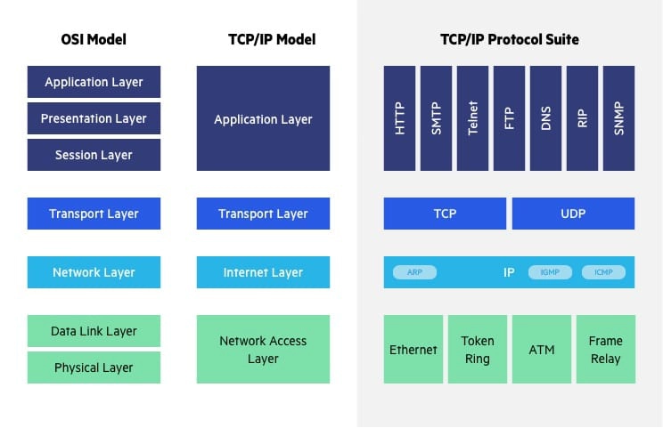

The [Transfer Control Protocol/Internet Protocol](https://www.imperva.com/learn/application-security/tcp-transmission-control-protocol/) (TCP/IP) is older than the OSI model and was created by the US Department of Defense (DoD). A key difference between the models is that TCP/IP is simpler, collapsing several OSI layers into one:

* OSI layers 5, 6, 7 are combined into one Application Layer in TCP/IP
* OSI layers 1, 2 are combined into one Network Access Layer in TCP/IP – however TCP/IP does not take responsibility for sequencing and acknowledgement functions, leaving these to the underlying transport layer.

Other important differences:

* TCP/IP is a functional model designed to solve specific communication problems, and which is based on specific, standard protocols. OSI is a generic, protocol-independent model intended to describe all forms of network communication.
* In TCP/IP, most applications use all the layers, while in OSI simple applications do not use all seven layers. Only layers 1, 2 and 3 are mandatory to enable any data communication.

## What is TCP/IP model?

The TCP model stands for **Transmission Control Protocol,** whereas IP stands for **Internet Protocol**. A number of protocols that make the internet possibly comes under the TCP/IP model. Nowadays, we do not hear the name of the TCP/IP model much, we generally hear the name of the IPv4 or IPv6, but it is still valid. This model consists of 4 layers. Now, we will look at the diagrammatic representation of the [TCP/IP model](https://www.javatpoint.com/computer-network-tcp-ip-model).

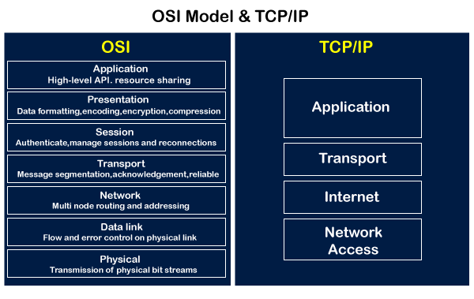

As shown in the above diagram, the TCP/IP model has 4 layers, while the OSI model consists of 7 layers. Diagrammatically, it looks that the 4 layers of the TCP/IP model exactly fit the 7 layers of the OSI model, but this is not reality. The application layer of the [TCP/IP](https://www.javatpoint.com/tcp-ip-full-form) model maps to the first three layers, i.e., application, session, and presentation layer of the OSI model. The transport layer of the TCP maps directly to the transport layer of the OSI model. The internet layer of the TCP/IP model maps directly to the network layer of the OSI model. The last two layers of the OSI model map to the network layer of the TCP/IP model. TCP/IP is the most widely used model as compared to the OSI model for providing communication between computers over the [internet](https://www.javatpoint.com/internet).

### Similarities between the OSI and TCP/IP model

**The following are the similarities between the OSI and TCP/IP model:**

* **Share common architecture**

Both the models are the logical models and having similar architectures as both the models are constructed with the layers.

* **Define standards**

Both the layers have defined standards, and they also provide the framework used for implementing the standards and devices.

* **Simplified troubleshooting process**

Both models have simplified the troubleshooting process by breaking the complex function into simpler components.

* **Pre-defined standards**

The standards and protocols which are already pre-defined; these models do not redefine them; they just reference or use them. For example, the Ethernet standards were already defined by the IEEE before the development of these models; instead of recreating them, models have used these pre-defined standards.

* **Both have similar functionality of 'transport' and 'network' layers**

The function which is performed between the **'presentation'** and the **'network'** layer is similar to the function performed at the **transport** layer.

Differences between the OSI and TCP/IP model

| It stands for **Open System Interconnection.** | It stands for **Transmission Control Protocol.** |
| --- | --- |
| OSI model has been developed by ISO (International Standard Organization). | It was developed by ARPANET (Advanced Research Project Agency Network). |
| It is an independent standard and generic protocol used as a communication gateway between the network and the end user. | It consists of standard protocols that lead to the development of an internet. It is a communication protocol that provides the connection among the hosts. |
| In the OSI model, the transport layer provides a guarantee for the delivery of the packets. | The transport layer does not provide the surety for the delivery of packets. But still, we can say that it is a reliable model. |
| This model is based on a vertical approach. | This model is based on a horizontal approach. |
| In this model, the session and presentation layers are separated, i.e., both the layers are different. | In this model, the session and presentation layer are not different layers. Both layers are included in the application layer. |
| It is also known as a reference model through which various networks are built. For example, the TCP/IP model is built from the OSI model. It is also referred to as a guidance tool. | It is an implemented model of an OSI model. |
| In this model, the network layer provides both connection-oriented and connectionless service. | The network layer provides only connectionless service. |
| Protocols in the OSI model are hidden and can be easily replaced when the technology changes. | In this model, the protocol cannot be easily replaced. |
| It consists of 7 layers. | It consists of 4 layers. |
| OSI model defines the services, protocols, and interfaces as well as provides a proper distinction between them. It is protocol independent. | In the TCP/IP model, services, protocols, and interfaces are not properly separated. It is protocol dependent. |
| The usage of this model is very low. | This model is highly used. |
| It provides standardization to the devices like router, motherboard, switches, and other hardware devices. | It does not provide the standardization to the devices. It provides a connection between various computers. |